- Install Seaborn in your Python environment and use it to create a histplot showing the distribution of delivery times (in minutes) for 50 Zomato food orders. Generate random data if needed.

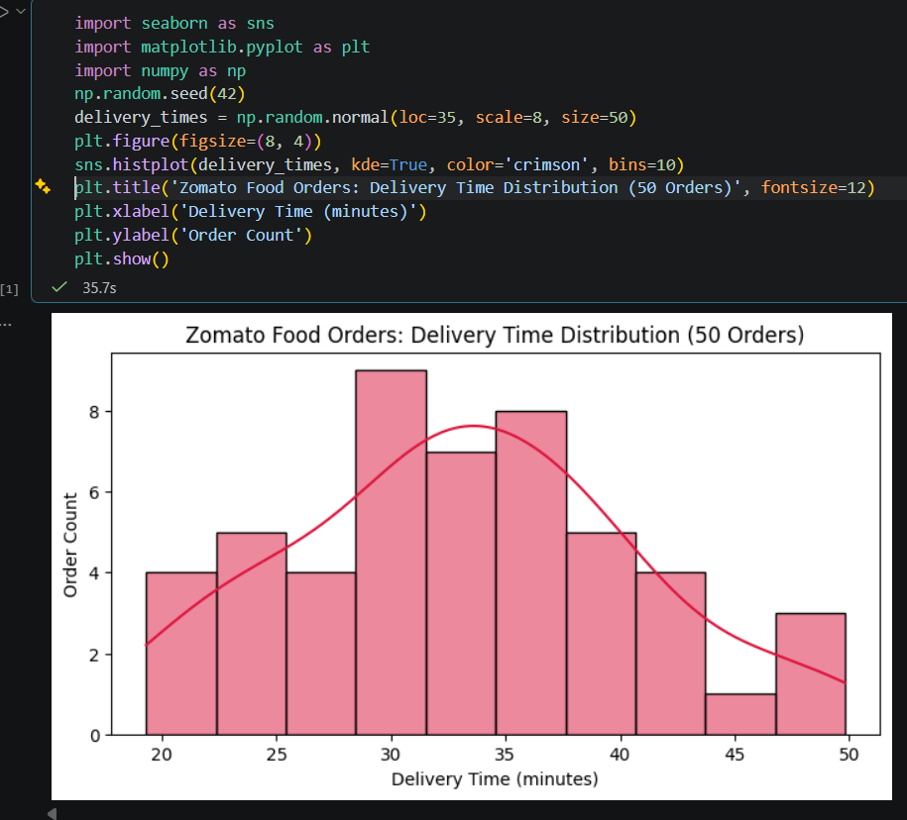

- Load the 'tips' dataset from Seaborn and create a boxplot to visualize the distribution of total bill amounts by day of the week, similar to how Zomato might analyze spending patterns across weekdays.
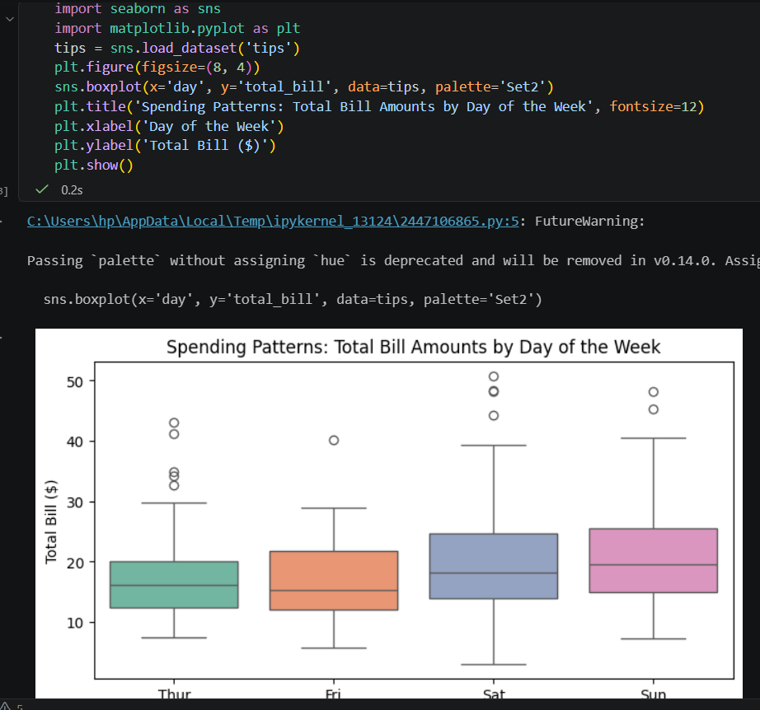

- Simulate IPL match scores for 8 teams and use a violinplot to compare the run distributions per team. Style your plot using the 'darkgrid' Seaborn theme.
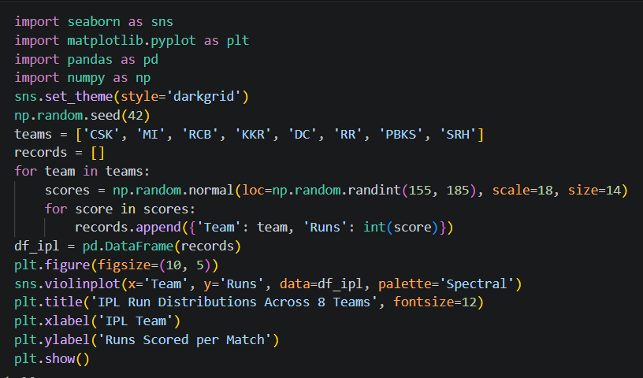
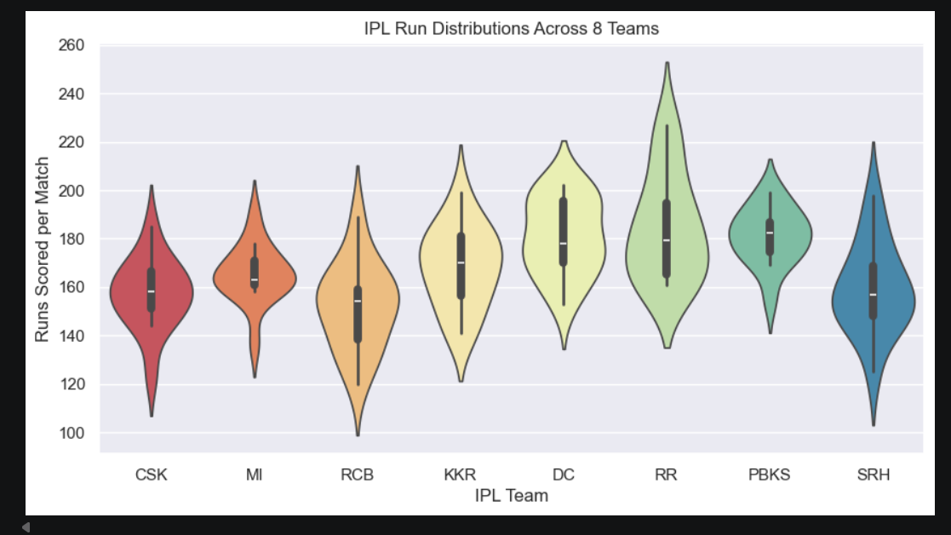

- Create a countplot that displays the number of songs per genre from a list of 40 Spotify tracks, with at least 4 different genres represented. Use a Python list or pandas DataFrame to store your data, then plot with Seaborn.
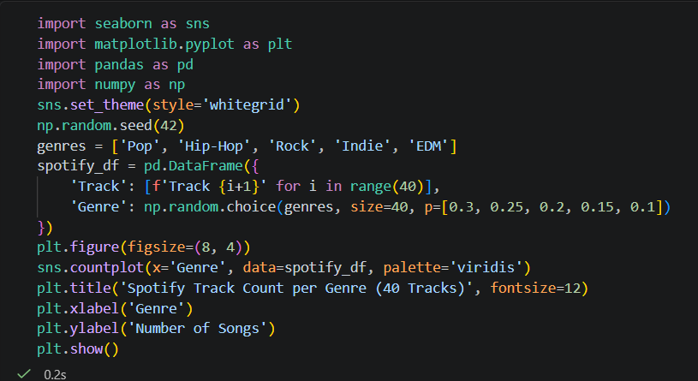
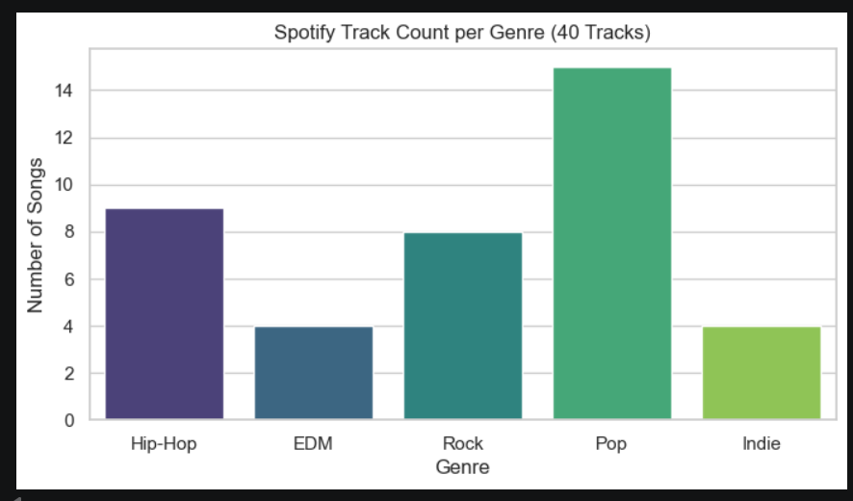

- Use Seaborn's kdeplot to visualize the distribution of daily step counts for a week, as if analyzing data from a fitness app. Apply the 'whitegrid' theme and customize the plot color.
